Project Development Phase

Delivery of Sprint - 4

Date | 17 November 2022
Team Members | Pavithra L, Priyadharshini B,Nivedhitha V,Rajalakshmi R
Team ID | PNT2022TMID02444
Project Name | AI based discourse for Banking Industry

Customizing our chatbot through webchat

Extracting the script for chatbot from webchat to insert it into the html code

Preview of chatbot in watson assistant server

HTML code for designing front end of our webpage.
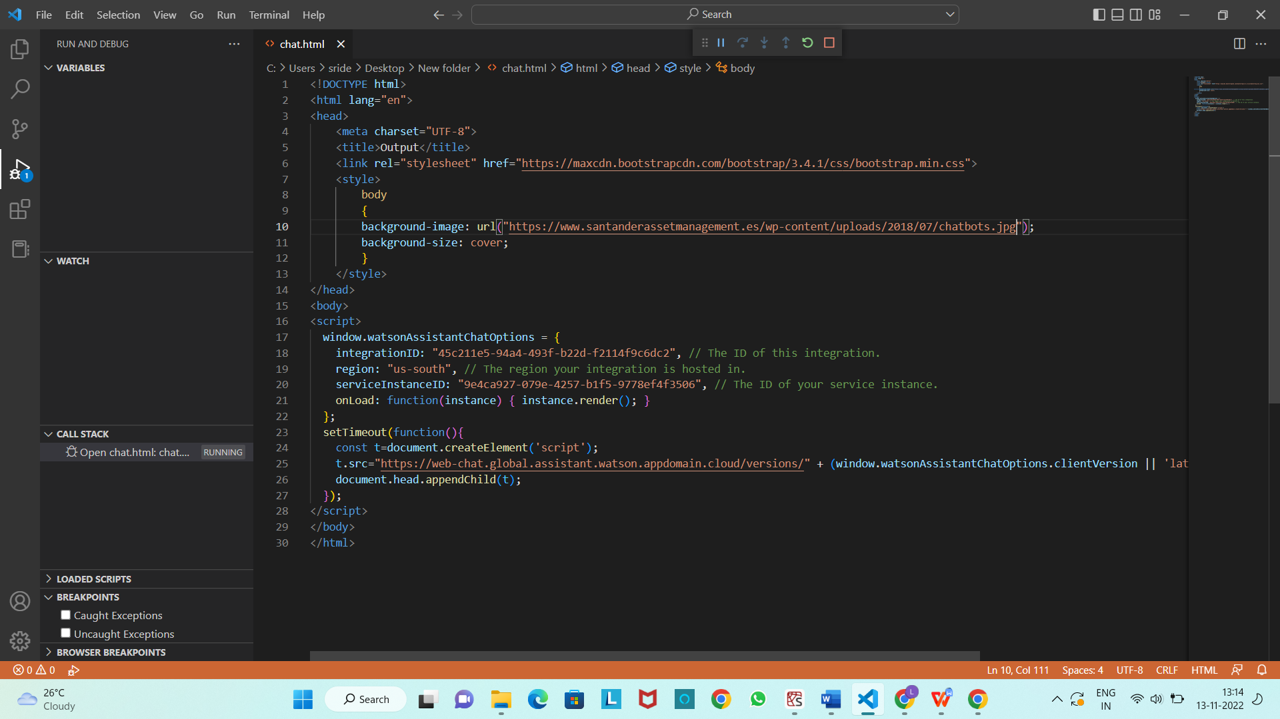
And running it in application through flask
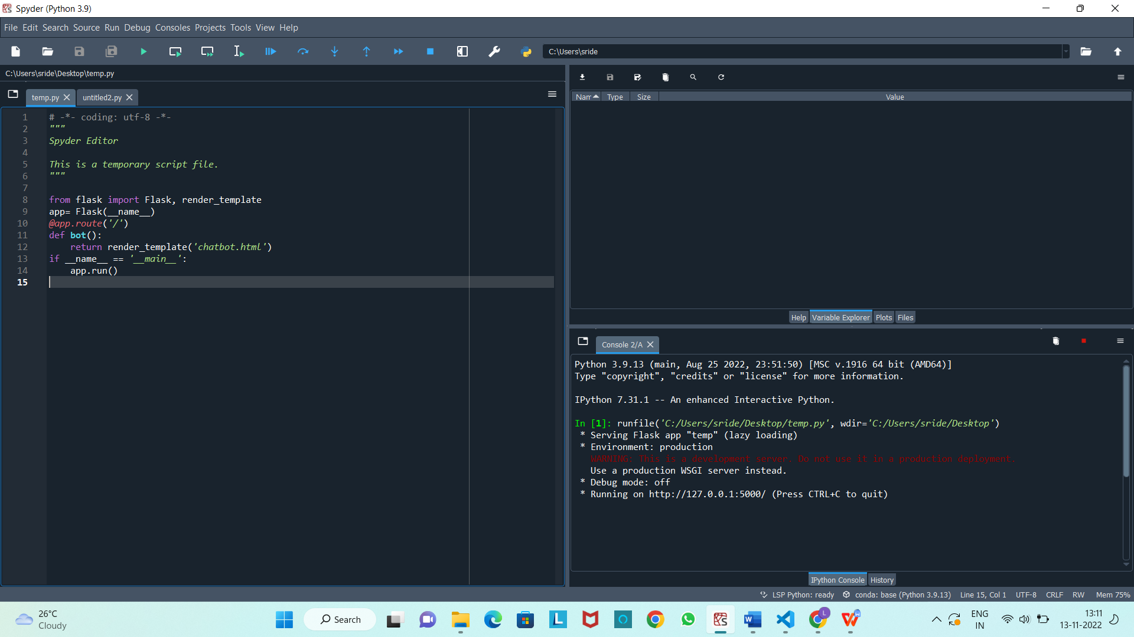

Final output of the chat bot executed in own web server.
